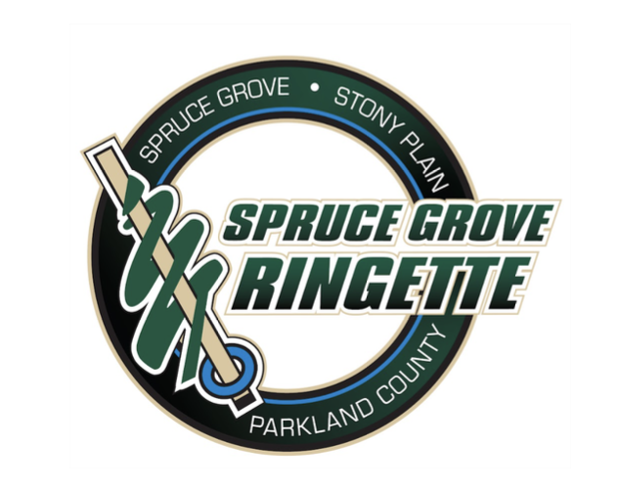

Spruce Grove Ringette Association
Evaluation Process

Introduction
SGRA has compiled this information to outline the general principles and procedures behind the upcoming season evaluation process. The primary goal is to evaluate athletes fairly, consistently, and to place each player on teams with athletes of similar ability through a 3rd party impartial evaluation process. Throughout this document, there will be procedures outlined which are unique to specific age divisions or level of play. SGRA evaluations are conducted in accordance with the SGRA Team Formation Policy.

At the beginning of the ringette season, athletes from all divisions will have the opportunity to attend up to 5 evaluation ice times, depending on the division and level of play. This process will provide an impartial assessment of each athlete’s overall ringette skill level and determine their appropriate playing level within their division. This process will also assist SGRA in determining level of play and forming competitively balanced teams within each division that may have more than one team at a given level.

It is important athletes attend all their designated ice times. Absences from evaluation skates may have a significant impact on final placement as a zero score may be included in their final sum score for team formation. Exceptions, such as illness or injury, may be taken into consideration. In this case, a written explanation from the athlete or parent/guardian, along with supporting medical documentation, may be required, and must be submitted to the appropriate Division Director as soon as possible. It is understood certain unavoidable factors may contribute to an athlete being unable to attend an ice time, and for these situations, the Oversight Committee will conduct a review and decide as to the appropriate team placement on a case-by-case basis.

Roles & Responsibilities
A combination of volunteers and a 3rd party evaluation company, will participate in the evaluation process.
- 3rd Party Evaluators – SGRA hires 3rd party evaluators. Sports Evaluations Ltd. has been selected for the 2026/27 season and will be responsible for UAA timing, scrimmage evaluations and any skills events (if utilized).
- Director of Evaluations – Liaises directly with the 3rd party evaluations company and SGRA board members to ensure guidelines set out by Sports Evaluations Ltd. are followed.
- Division Directors – Responsible for organizing player skate groups, jersey number/color assignments and recruiting volunteers to assist with evaluations. Directors are also responsible for all communication with players and parents in conjunction with the 3rd party evaluation company.
- Director of Coaching Development – Responsible for organizing interviews for Coach Selection Committee with potential Head Coach candidates as well as provide feedback and/or recommendations to selected Head Coaches for possible Assistant Coach candidates. SGRA Team Selection Process to be followed.
- Director of Player Development – Liaising with Divisional Directors and supporting the Director of Evaluations where required.
- Director of Ice Acquisition and Allocation – Works with the Director of Evaluations, Director of Player Development and Division Directors to establish and communicate ice schedule for evaluations.
- President – Responsible for the governance of SGRA’s Bylaws and Policy during the evaluation process.
- Vice President/ Director of Operations – Responsible for supporting Directors and providing guidance and direction as needed.

Oversight Committee To maintain the integrity of evaluation policies, processes and decision making, SGRA uses an Oversight Committee. The objective of the Oversight Committee is to ensure policies are being followed when decisions are being made and not to overturn a committee’s decision based on a difference of opinion. The Oversight Committee is the final authority. Should a recommendation be rejected by the Oversight Committee, it falls to them to implement a solution and/or an alternative recommendation.

Members of the Oversight Committee must include a minimum of three people, two of which must be board members, from the following:
- Director of Player Development
- Appropriate Division Director
- Director of Coaching Development
- Director of Evaluations
- President and/or Vice President if applicable or required
- Additional Directors or Board Members, where a perceived conflict of interest may exist
- Individual with advanced competitive knowledge or experience in sport

SGRA Evaluation Sessions Evaluations aim to begin the last week of August. All sessions begin with the intent of forming teams as early as possible while still maintaining a fair and open process. It is SGRA’s intention to allow for an opportunity for conditioning skates, or practice UAA’s (Universal Athlete Assessments), prior to the commencement of evaluations. This will depend on RAB evaluation directives and ice availability.

Team selection will be based on the following:
- U10 – UAA + up to 3 games
- U12 – UAA + up to 3 games
- U14 – UAA + up to 3 games
- U16 – up to 4 games
- U19 – up to 4 games

All communications regarding ice times and groupings will be communicated by the appropriate Division Director, by email and the division webpage on the SGRA website and provided by Sports Evaluations via email.

Evaluators SGRA is proud to have contracted an independent evaluation company (Sports Evaluations Ltd.) at each age level for this upcoming season. These independent evaluators are qualified ringette players and coaches with AA and National experience. All evaluators will be contracted through our 3rd party independent evaluation service of Sports Evaluations Ltd. and will work with the board closely throughout the evaluation process.

Sports Evaluations Ltd will:
- Provide scores for all skill categories for every evaluation ice time to SGRA.
- Provide rankings and reports of each category for team selection upon completion of the evaluation process to SGRA.
- Work with the Director of Evaluations for each session.
- Give a rating in every category for any athlete assigned to them.
- Provide emails to parents and guardians on next skate times.

PLAYER EVALUATION PROCESS

Universal Athlete Assessment (UAA): Ringette Alberta : Website by RAMP InterActive
Developed by Ringette Alberta, these are repeatable, timed skill measurements which do not require evaluators but will be coordinated by Sports Evaluations Ltd. with the help of volunteers. A parent volunteering with a child on the ice must remove themselves from the station where their child is evaluating at and switch with another volunteer on the ice at the time.

All U10, U12, and U14 athletes will be required to attend their UAA ice session. This UAA score will be used by SGRA as a separation skate and the players will be tiered into the first game skate after the UAA scores are tallied. There will be movement of players up or down after the first and second game skate to ensure players are scored and ranked with similar skill levels which leads to more accurate final rankings for team selection.

As explained by Ringette Alberta, UAA’s are as follows: For U10, four timed drills will be used. These timed drills are forward skating, backward skating, start and stop test, and ring agility weave. For U12 and U14, there are five drills, the ones mentioned previously plus the Butterfly.

Athletes may be invited to a practice UAA skate, prior to the assessment, to familiarize themselves with the process and environment. Each drill will be explained (and demonstrated, if needed) to the group before proceeding. All U10/U12 athletes will complete the UAA as a skater - NO goalie equipment.

** Minimum team level will be determined by relative team score for U10, U12 and U14 UAA team scores as per Ringette Alberta guidelines and Tiering Policy. (Ringette Alberta 4.0 Tiering Policy). Final levels are subject to change based on further comparison within Black Gold League.

U10 Division
The U10 division is considered Children’s Ringette by Ringette Alberta and is divided into steps. They are:
- Active Start
- Step 1
- Step 2
- Step 3

The U10 division is not a tiered division. The “steps” within the U10 division have been created so that athletes of varying skill, experience and readiness can be successful. It recognizes the importance of the athlete, not just an athlete’s chronological age or skill set. This holistic approach is optimal for long-term athlete development.

After each game session, the evaluation company may move 1-3 players forward who are deemed exceptional. They would therefore be assigned to the top team. This is a necessary step to allow the middle core additional ice time, allowing evaluators more time to rank players in the appropriate order.

Five considerations when grouping players are:
- Fine and gross motor skills
- Skating
- Ringette IQ
- Social-emotional readiness
- Chronological age

A tiered program would only look at an athlete’s ringette skills. The Active Start/Step model recognizes that children do not develop on the same linear curve, nor do they develop on one curve in all four areas. Every child is an individual and therefore will not necessarily progress from one step to the next in a linear fashion.

The scores provided by Sports Evaluations will be used for team selection to create the team recommendations according to Ringette Alberta Guidelines.

Children who are seven years old and under and have never played ringette before, register in Active Start. Contact the U10-Active Start Division Director if clarification is required. For Active Start, there is no formal evaluation process. You will be contacted by your Division Director with the first on-ice session.

For U10 Steps 1 through 3, the evaluation process has two components:
- The Universal Athlete Assessment (UAA) as described above.
- A series of game play situations. Each player receives multiple opportunities to demonstrate their skills in homogeneous groups. (Coaches may be allowed on the ice during scrimmage skates within U10)

Following the completion of evaluations, Head Coaches will be given a formed team for their season. This aligns with the principles of Children’s Ringette.
Please refer to APPENDIX E: U10, U12, AND U14 EVALUATION PROCESS FLOWCHARTS.
*Note: Final levels are determined by relative UAA scores as per Ringette Alberta.
If you have any questions, please contact the Director of Active Start & U10: U10dir@sprucdegroveringette.com

U12 Division
The U12- division is still considered Children’s Ringette by Ringette Alberta. This will be an athletes first experience of playing within tiered divisions. To determine player placement, a consistent evaluation process will be utilized to allow for an impartial assessment of a player’s total ringette skillset. For the process to be effective, players must attend the evaluation ice times they are assigned.

Team Levels
- U12 teams will be made up of a combination of A, B, and C levels.

Following the completion of evaluations, the top 90% of players will be protected and the A Coach will be allowed to select the remaining 10%. Once the A team selection has been completed, the B, then C Coach will follow the same process as mentioned above. The spirit of this selection process is to ensure proper goalie allotment for developing athletes.

These selections will be attended and approved by the Oversight Committee in accordance with SGRA Policies and Guidelines. Team size will be determined by the association based on balancing the number of players among the levels in each division accordingly prior to team selection. All rosters for A, B and C teams will be posted once the process and all picks are completed.

If you have any questions, please contact:
- Director of U12 U12dir@sprucegroveringette.com

U12 Draft

The selected Head Coach and one Assistant Coach if selected prior will attend the draft.
- The Head Coach and Assistant Coach must select their child when they are the highest remaining skater being selected.
- Players tied in the ranking for the last protected/mandatory spot will be included in the protected players and the number of coach’s picks are reduced accordingly.
- The Oversight Committee will determine the acceptable range of players eligible to be coach’s pick.
- For two team drafts, coach pick zone may double.
- In the event of two or more teams in the same division and level, the team or Head Coach who selects first is based upon the cumulative score of the Head Coach and Assistant Coach’s child’s score. The team or Head Coach with the lowest cumulative score will select first and the team or Head Coach with the highest cumulative score will select last.
- Upon completion of the draft, the coaches will be asked to confirm they agree that the teams are equitable.
- The Oversight Committee will have final say on team selection.
- The Coaches and Oversight Committee will sign off completing the draft process and team selection.

U12 & U14 Divisions
The evaluation process will be a combination of two components:
- The Universal Athlete Assessment (UAA) as described above.
- A series of game play situations. Each player receives multiple opportunities to demonstrate their skills in homogeneous groups.

After each game session, the evaluation company may move 1-3 players forward who are deemed exceptional. They would therefore be assigned to the top team. This is a necessary step to allow the middle core additional ice time, allowing evaluators more time to rank players in the appropriate order.

No first years are to sit for the final skate in any given division (carry forwards).

U12 & U14 Game Play
All subsequent ice times will be game play format. Game play may take various forms. All players will have a cumulative evaluation score based on all evaluations to date (including UAA scores) to determine subsequent ice times. At the end of the evaluation process, Sports Evaluations Ltd. will rank athletes based on all evaluation scores to generate the draft list or potential team formation rankings.

Some of the key concepts and guidelines are:
- Like skilled players compete against each other after the separation skate.
- Consistent evaluators for ice times within a division.
- After each ice time, all players who participated in the ice time may have a cumulative score. The scores from each session will be used and considered when movement of players are made to determine placement for the next game skate. Recommendations from Sports Evaluations will be used for player movement.
- Evaluation scores will be compiled by use of an online evaluation application. The Divisional Directors and Coordinator of Evaluations will oversee this process and have access to scores in real time.

U12 & U14 Game Play Process
- Each player will be assigned a pinnie or jersey color and number for each game. Please arrive early for each evaluation time.
- Game play may consist of 3v3, 4v4, 5v5, etc. with the goal being equal shift time.
- For U14, evaluation drills may be incorporated into the scrimmage to start each session.
- Fluid line changes/ line changes on cue will be outlined to the players prior to the start of the game with the goal of equal shift opportunity for all players.
- A referee will be scheduled for evaluations games. Referee discretion will be used regarding rules/calls to ensure optimal game flow throughout the ice time.
- It is important to note that for U14 scrimmages, players may not be playing in their primary position at all times. Bench volunteers should try their best to rotate players based on their declared or primary position. Player’s primary position will be noted for each athlete, so bench volunteers are aware and will be marked in the evaluation app for the evaluators.
- For U12, bench volunteers should try their best to rotate players equally and fairly through all scrimmage skates. At this level, it is not critical to rotate based on position as it is still declared as Children’s Ringette.
(Note: Parent/Coach Volunteers on the bench/ice are not permitted to instruct or coach any player through the process)

Evaluators are scoring on four areas: from a 1-9 scale
  - Skating
  - Skills - Shooting, Passing, & Receiving, game skills (offensive/defensive), checking, ring handling
  - Game sense – Offensive/ Defensive, understanding of rules
  - Intangibles – work ethic, compete, battle, want, will
- A score will be recorded for each player on each of the four skill categories. The score will be based on each player’s skill as compared to other players on the ice.

U14 to U19 Divisions
- U14 teams may be made up of a combination of A, B and C levels.
- U16 teams may be made up of a combination of A, B and C levels.
- U19 team(s) may be made up of a combination of A, and B levels.

** Team roster sizes will be dependent on the number of players registered in each division. The actual number will be determined by the Oversight Committee and in accordance with SGRA Bylaws and Policies and Ringette Alberta Guidelines.
** For players wishing to be evaluated as a part-time or full-time goalie, see the last section in this document.
** Upon selection of the Capital Region Ringette U14AA, U16AA, and U19AA teams, unsuccessful players will be released to attend evaluation skates with their home association.

If you have any questions, please contact:
- Director of U14 U14dir@sprucegroveringette.com
- Director of U16 U16dir@sprucegroveringette.com
- Director of U19 U19dir@sprucegroveringette.com

U14 & U19 Mandatory Selections
As athletes move into more competitive levels and/or older divisions, athletes may move into designated positions (Goalie, Forward, Defence, Centre). Players may identify their primary and secondary positions during registration. Bench volunteers will strive to organize skaters into their preferred positions during scrimmages. This will be considered, however during team selection and throughout the season, coaches ultimately decide where an athlete will play.

Athletes will be evaluated in two categories:
  - Goalies
  - Skaters (Forward, Defence, Centre)
Rationale: To ensure the most skilled athletes are ranked in order, regardless of position.

New for 2026/2027: As part of the ongoing effort to strengthen the AA program in the Capital Region, all associations have collaborated to develop a revised framework for AA programming.
U14AA, U16AA, and U19AA athletes progress through a sequence of evaluations beginning at their regional host association and culminating in joint centralized evaluations and team selection. Those athletes not selected to a Capital Region AA team return to their home association for participation in local evaluations.

House League Teams
For U14, the top 70% of skaters will be protected and the A coach will be allowed to select the remaining 30%. Once the A team selections have been completed and the final roster posted, the B coach will follow. The top 70% of skaters will be protected, and the B coach will be allowed to select the remaining 30%. Once the B coach selections have been completed, the C coach will follow the same as mentioned above.

For U16, the top 60% of skaters will be protected and the A coach will be allowed to select the remaining 40% for the roster. Once the A coach selections have been completed and the final roster posted, the B or C coach will follow the same process as mentioned above. The top 60% of skaters will be protected and the B or C coach will be allowed to select the remaining 40%.

For U19, the top 50% of skaters will be protected and the A coach will be allowed to select the remaining 50% of the roster. Once the A coach selections have been completed and A roster announced, the B coach will follow the same process as mentioned above. The top 50% of skaters will be protected and the B coach will be allowed to select the remaining 50%.

These selections will be attended and approved by the Oversight Committee in accordance with the SGRA Policies and Guidelines. Team size will be determined by the association based on balancing the number of players among the levels in each division accordingly prior to coach selection.

Sports Evaluations Ltd. will provide rankings for each category to SGRA and not specific feedback for each player. They are providing our rankings for team selection only and not a scouting service.

Final team level in accordance with Ringette Alberta’s Tiering policy states – ‘Minimum team level will be
determined by relative UAA team score’. In other words, if a team’s UAA score says the team is an A team, for example, then Ringette Alberta considers that team to be an A team unless and until that is changed through the BGL Team Advance/Retreat process.

U14 to U19 Draft
- The selected Head Coach and one Assistant Coach if selected prior will attend the draft.
- The Head Coach and Assistant Coach must select their child when they are the highest remaining skater being selected.
- Skaters tied in the ranking for the last protected/mandatory spot will be included in the protected skaters and the number of coach’s picks is reduced accordingly.
- The Oversight Committee will determine the acceptable range of skaters eligible to be coach’s pick.
- For two team drafts, coach pick zone may double.
- In the event of two or more teams in the same division and level, the team or Head Coach who selects first is based upon the cumulative score of the Head Coach and Assistant Coach’s child’s score. The team or Head Coach with the lowest cumulative score will select first and the team or Head Coach with the highest cumulative score will select last.
- Upon completion of the draft, the coaches will be asked to confirm they agree that the teams are equitable.
- The Oversight Committee will have final say on team selection.
- The Coaches and Oversight Committee will sign off completing the draft process and team selection.

Draft Order
The order will follow a snake as below:
Coach A | Coach B
1 | 2
4 | 3
5 | 6
8 | 7
9 | 10
12 | 11
13 | 14
16 | 15
17 | 18
20 | 19
21 | 22
24 | 23
25 | 26
28 | 27
29 | 30
32 | 31

If there is more than one team in the same division and same level, an additional ice time may be used as an inter-squad game to ensure that the two teams are drafted into balanced groups within the division level.

U16 & U19 Divisions
The evaluation process will include various game play situations. The main concept of the process is to accumulate evaluation scores for each player with each ice time.

Some of the key concepts and guidelines are:
- Like skilled players compete against each other.
- Consistent evaluators for ice times within a division.
- After each ice time, all players who participated in the ice time will have a cumulative score. The scores will then be used to group the players for the subsequent ice time or to determine placement in the draft.
- Evaluation scores will be compiled by use of an online evaluation application. The Divisional Directors and Coordinator of Evaluations will oversee this process

After each game session, the evaluation company may move 1-3 players forward who are deemed exceptional. They would therefore be assigned to the top team. This is a necessary step to allow the middle core additional ice time, allowing evaluators more time to rank players in the appropriate order.

U16 to U19 Game Play Process
Each skater will be assigned a pinnie colour and number for each skate. These may change from game to game.
- Game play may consist of 3v3, 4v4 5v5, etc.
- For U16 and U19, evaluation drills may be incorporated into the scrimmage to start each session.
- Fluid line changes with the goal of equal shift opportunity for all players.
- Skaters will be reorganized throughout the evaluation skates to prevent the same skaters from playing together on every shift.
- A referee will be scheduled for evaluations games. Referee discretion will be used regarding rules/calls to ensure optimal game flow throughout the ice time.
(Note: Parent/Coach Volunteers on the bench are not permitted to instruct or coach any player through the process)

Evaluators are scoring on four areas: from a 1-9 scale
  - Skating
  - Skills - Shooting, Passing, & Receiving, game skills (offensive/defensive), checking, ring handling
  - Game sense – Offensive/ Defensive, understanding of rules,
  - Intangibles – work ethic, compete, battle, want, will
- A score will be recorded for each skater on each of the skill categories as well as evaluator comments. The score will be based on each skater’s skill as compared to other skaters on the ice. Athletes will be grouped with athletes of similar skill level.
- Sports Evaluations Ltd. will provide rankings for each category and not specific feedback for each player. They are providing our rankings for team selection only and not a scouting service.
- All efforts will be made to try and place athletes in positions of choice for 5 on 5 play, but due to varying numbers of players this may not always be possible.

For all goalies (U14 to U19)

- At U10, players will not be evaluated as goalies.
- For U12+, goalies may be assessed by a goaltender evaluator during game play in a maximum of 2 scrimmages
- For U14+ If a player has chosen to be full or part time goalie, they will be evaluated as a goalie during game play.
- In addition to the scrimmage evaluation, full time goaltenders will also have the opportunity, dependent on ice availability, to evaluate in a separate goaltender skill assessment (U14-U19).
- The Division Directors and/or bench volunteer will ensure that each full-time goalie receives equal playing time. Where requested by part time goalies, they will be given opportunity to be evaluated as a goalie while attempting to give them a fair evaluation for their time playing out.
- There will be several skills evaluated during these ice times and goalies will receive a score on each skill being evaluated.

The skills evaluated will be:
  - Goalie Skating
  - Goalie Positioning
  - Goalie Ring Skills & Stick Work
  - Goalie Mobility

EVALUATION WEIGHTINGS

Number of games and weightings are subject to change based on ice availability and evaluator recommendations.

U10  Skills / UAA – 40%  Game 1 – 20%  Game 2 – 20%  Game 3 – 20% | U12  Skills / UAA – 10%  Game 1 – 30%  Game 2 – 30%  Game 3 – 30%
U14  Skills / UAA – 10%  Game 1 – 30%  Game 2 – 30%  Game 3 – 30% | U16  Scrimmage 1 – 25%  Scrimmage 2 – 25%  Scrimmage 3 – 25%  Scrimmage 4 – 25%
U19
Scrimmage 1 – 25%
Scrimmage 2 – 25%
Scrimmage 3 – 25%
Scrimmage 4 – 25%

  - U10- U14 minimum team level will be determined by final UAA score.
  - U14-U19 Goalie weightings - 40% for goalie skills session with the remaining 60% based on scrimmage play.
  - Skills skates for U16/U19 may be required to determine teams for initial scrimmage play, in which case up to 3 equally weighted scrimmage skates will follow

DISPUTE RESOLUTION PROCESS
Sports Evaluations customer service policy includes a philosophy and commitment rooted in leadership and geared to providing good quality, professional evaluation service that is implemented through transparent expectations and a transparent process. It is important that there is good communication and thorough information provided to SGRA during the evaluation process and at its conclusion. Sports Evaluations provides reporting for team selection purposes.

If you wish to provide a formal written dispute of scores, there is a fee of $500 along with your application. This application can be received from each category director. It is also important there exist a mechanism for feedback and dispute resolution. In the event of a dispute, Sports Evaluations is proposing bringing arbitration as the form of alternative dispute resolution. The arbitrator panel shall be comprised of one representative Sports Evaluations, one representative of the SGRA and one parent representative: each having an equal vote. The decision of this arbitrator panel shall be binding on the participants.

PROTECTED PERCENTAGE
U16 team (60%) of 14 skaters
0.6 x 14 = 8.4
8 protected, 6 coach pick

As outlined in each division for U12-U19, a percentage of skaters are protected. The formula to determine these numbers will be based on team roster size and the designated percent protected rounded to the nearest whole number. U16 is used as an example.

AFFILIATION
Player affiliation allows a team to replace absent, sick, injured, or suspended players on a game-by-game basis. See SGRA and Ringette Alberta Affiliation Policies. Potential and appropriate affiliates will be discussed upon completion of each team selection with each applicable Head Coach.

APPENDIX A: UAA Frequently Asked Questions (FAQ)

How will the athletes be assessed?
The Universal Athlete Assessment (UAA) is a series of five timed drills (four timed drills for U10), which will be used in conjunction with scrimmage scores, and prior team placement to place players into appropriate groupings. A Ringette Alberta YouTube video details more about the UAA. The video details seven UAA drills; the five modified drills used are:
- forward skating,
- backward skating,
- start and stop,
- ring agility weave,
- butterfly (U12 & U14 only)

A Ringette Alberta YouTube video shows UAA drills: https://www.youtube.com/watch?v=FEW0SsOjDCw

Game play assessment is cumulative and is based on a 9-point scale. Players are evaluated on:
- Ring Skills = Ring Movement, Receiving, Passing, Shooting
- Skating, Effort and Competitiveness = Aggressiveness vs. Trepidation, Team Play, Attitude, Ability.
- Game Sense = Zone Awareness (defensive/offensive), Creating advantages, Player Support, Marking, Transition, Communication.
- Intangibles – work ethic, compete, battle, want, will

Will my child always be in the same evaluation group?
Not necessarily. UAA scores will determine initial groupings. After each ice time, players may be regrouped based on their evaluation scores (and applicable weightings) for subsequent ice times.

How many ice times are in the evaluation process?
- 1 practice UAA session (no evaluations take place): U10, U12, and U14
- 1 UAA testing day: U10, U12, U14 only and up to 3 game sessions
- Potential U16/U19 skills session - used to form teams for scrimmage play
- U16, U19 – up to 4 game sessions
- Goalie Skills Session (U14- U16)

What is Sports Evaluations providing?
Sports Evaluations Ltd will provide 4 evaluators to every ice time outside of UAA. They will also be providing rankings for each category for team selection purposes to SGRA. Sports Evaluations will be providing SGRA rankings for team selection only and not a scouting/feedback service. There is additional general data available to each parent should they wish for that data for an additional fee outside of the contracted service to SGRA.

When will I know my child’s first ice time?
You will be contacted by your Division Director about which sessions your child is required to attend. After the first ice session, Sports Evaluations will advise you when your next ice time is via email. Check the website and your email frequently for continuous updates to schedules.

When will I know who my child’s coach will be?
Volunteer coaches are a valuable component of SGRA. We value their time, energy, and commitment. We work closely with the Director of Coaching Development throughout the evaluation process to assign coaches to the appropriate teams as quickly as possible. Once all evaluation scores have been compiled, coaches will be selected and notified.

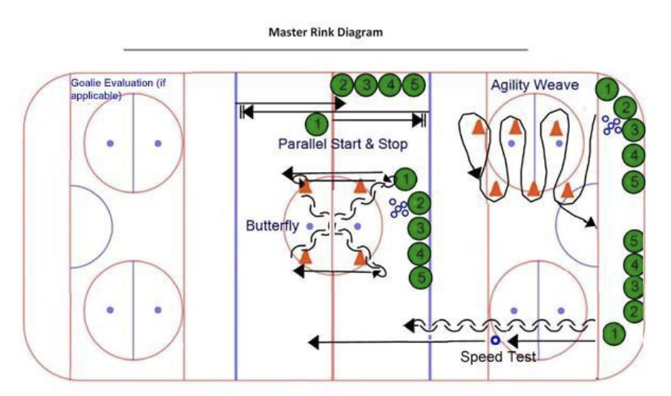
APPENDIX B: UAA Skills Rink Diagram

APPENDIX C: Weighting of Grading Scores by Age Division

 | U10 | U12 | U14 | U16 | U19
UAA SKILLS  SESSION | 40% | 10% | 10% | N/A | N/A
GAME PLAY  SESSIONS | 60% | 90% | 90% | 100% | 100%

APPENDIX D: Potential Team Selection Guidelines

Team Selection Guidelines
Division |  | U10 (3v3 for U10-S1 & S2)
DIVISION | STEP | MINIMUM ROSTER SIZE | MAXIMUM ROSTER SIZE | GOALIE
U-10 | 1 | 10 | 13 | N/A
U-10 | 2 | 10 | 13 | N/A
U-10 | 3 | 11 | 15 | N/A
Division |  | U12
DIVISION | LEVEL | MINIMUM ROSTER SIZE | MAXIMUM ROSTER SIZE | GOALIE
U-12 | A | 11 | 15 | N/A
U-12 | B | 11 | 15 | N/A
U-12 | C | 11 | 15 | N/A
Division |  | U14
DIVISION | LEVEL | MINIMUM ROSTER SIZE | MAXIMUM ROSTER SIZE | GOALIE
U-14 | A | 11 | 15 | 1 to 2
U-14 | B | 11 | 15 | 1 to 2
U-14 | C | 11 | 15 | 1 to 2
Division |  | U16
DIVISION | LEVEL | MINIMUM ROSTER SIZE | MAXIMUM ROSTER SIZE | GOALIE
U-16 | A | 11 | 15 | 1 to 2
U-16 | B | 11 | 15 | 1 to 2
U-16 | C | 11 | 15 | 1 to 2
Division |  | U19
DIVISION | LEVEL | MINIMUM ROSTER SIZE | MAXIMUM ROSTER SIZE | GOALIE
U-19 | A or B | 12 | 18 | 1 to 2

- Maximum roster sizes will be determined annually based on registration numbers in each division.
- Number of goalies per team will be at the discretion of the Oversight Committee. Applicable evaluation scores will assist in determining final placement in addition to ensuring each level has a goalie to make teams viable.

APPENDIX E: U10, U12, and U14 Evaluation Process Flowcharts

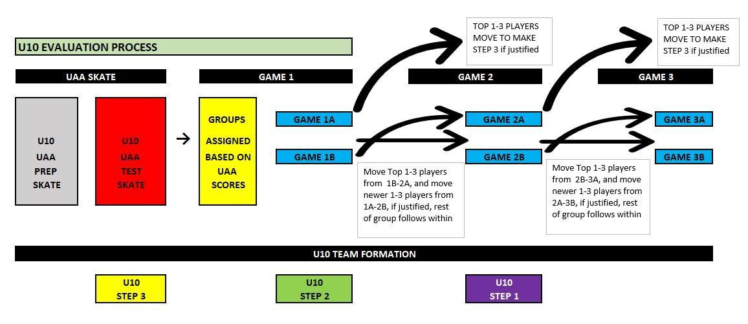

FINAL DESIGNATION OF TEAMS WILL BE DECIDED ON FINAL TRYOUT NUMBERS, UAA SCORES, AND SCORES FROM EVALUATORS.
No First Years are to sit for the final skate in any given division (carry forwards).
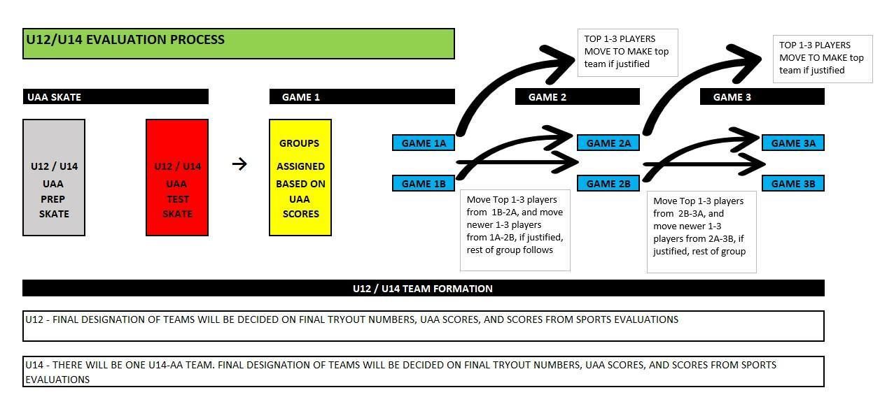

APPENDIX F: Evaluator App

